ASSIGNMENT – 3

ip addr : It displays the ip address
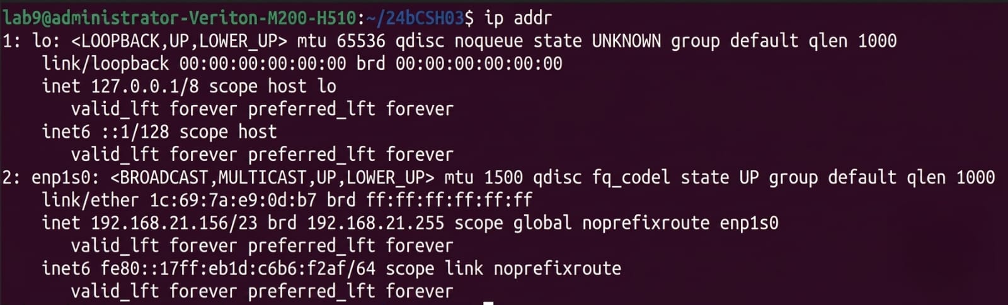

hostname : It displays host machine’s name.
hostname -i : Host machine’s ip address
hostname -I : To display all ip address configurations on net
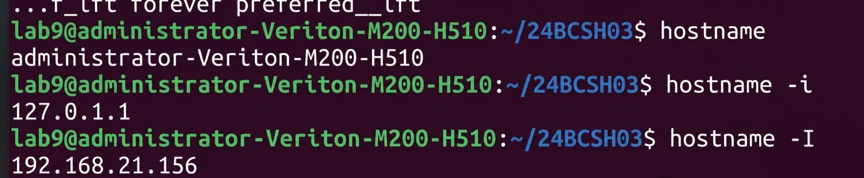

ping (ip) : It send packets to check connectivity
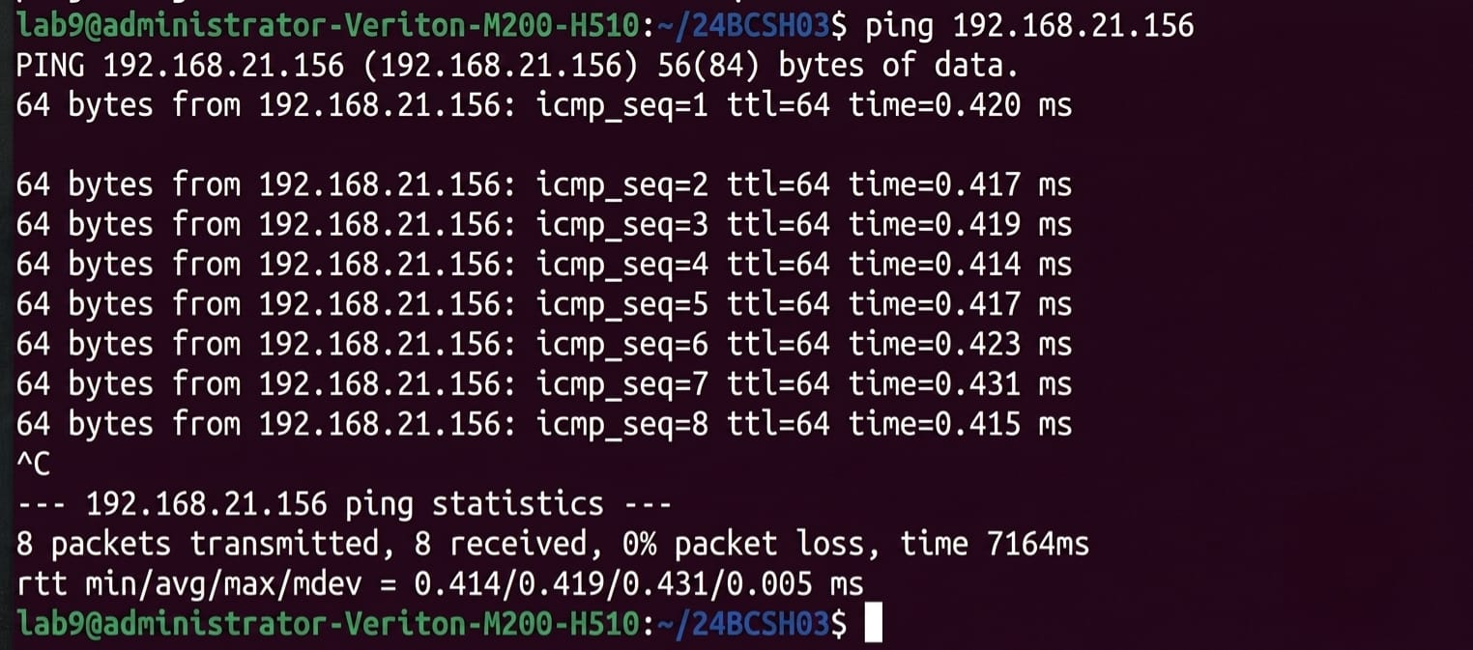

ip a :Displays all active network interfaces
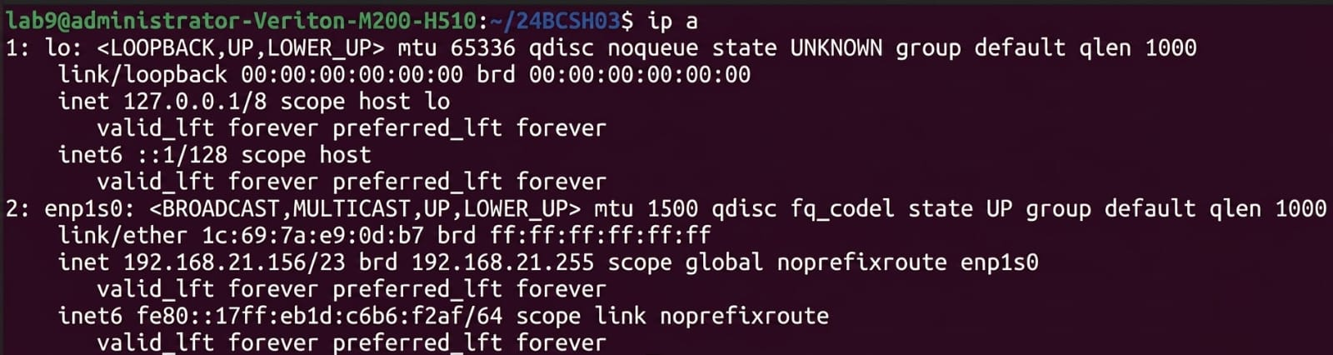

ip route : Display the kernel’s routing table
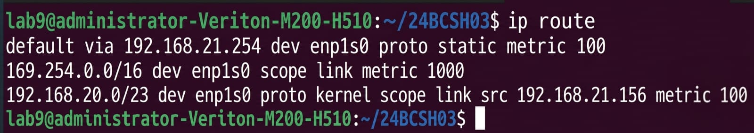

ip link: Displays system mac address


ss : Displays all active network connections and listing port
